

PIZZA HUT
SALES ANALYSIS

CONTENT
Pg.no
- About pizza hut……………………………………………………………………3
- Objective……………………………………………………………………………..4
- Introduction………………………………………………………………………..5
- Dataset overview…………………………………………………………………6
- Analysis based on sales……………………………………………………….7
- Basic analysis……………………………………………………………………….8
- Basic case study analysis……………………………………………………..9_10
- Insights from basic analysis………………………………………………….11
- Intermediate analysis…………………………………………………………..12
- Intermediate case study analysis………………………………………….13_14
- Insights from intermediate analysis……………………………………..15
- Advanced analysis………………………………………………………………..16
- Advanced case study analysis………………………………………………17_18
- Insights from advanced analysis…………………………………………..19
- Recommendation…………………………………………………………………20_21
- Conclusion…………………………………………………………………………..22

ABOUT PIZZA HUT

Pizza Hut is a global pizza restaurant chain founded in 1958 by Dan and Frank Carney. The brand entered India in June 1996, opening its first outlet in Bangalore. Since then, Pizza Hut has expanded rapidly across the country, becoming one of India’s most trusted and loved pizza brands.

The company is known for its wide selection of pizzas, sides, and desserts, along with both delivery and dine-in services. Pizza Hut’s growth in India highlights the success of adapting to local preferences introducing flavors and toppings that cater to Indian tastes while maintaining international standards.

In addition to its delicious food, Pizza Hut emphasizes quality service, hygienic preparation, and customer satisfaction. The brand’s presence in malls, high streets, and online delivery platforms ensures it stays accessible and convenient for customers.

Pizza Hut’s vision focuses on blending innovation, taste, and service, making it a leader in the pizza restaurant industry both in India and worldwide.

OBJECTIVE

The main objectives of Pizza Hut’s business strategy and data analysis include the following:

- Grow Online Orders:
Boost digital sales through the company’s official website and mobile app by offering discounts, easy payment methods, and real-time tracking.

- Introduce New Flavors:
Add new and exciting flavors using fresh, locally sourced toppings to maintain customer interest and satisfy diverse taste preferences.

- Enhance Customer Satisfaction:
Build strong customer loyalty by introducing rewards programs, personalized offers, and fun digital experiences such as augmented reality (AR) games.

- Improve Service Efficiency:
Speed up service time by optimizing order preparation and delivery processes to ensure faster and smoother pickups.

- Expand Market Presence:
Open more stores in new cities and regions, increasing accessibility and brand visibility across multiple market

INTRODUCTION

Pizza Hut is a globally recognized restaurant chain known for serving a wide range of delicious pizzas across the world. It was founded in 1958 in the United States by Dan and Frank Carney. Over the decades, Pizza Hut has expanded its operations to numerous countries, becoming one of the most loved pizza brands.

The brand entered India in June 1996, opening its first outlet in Bangalore. Since then, Pizza Hut has grown tremendously, earning the reputation of being India’s most trusted pizza brand. The company is known for offering high-quality pizzas, sides, beverages, and desserts, along with excellent dine-in and delivery services.

Pizza Hut is recognized for its wide menu of Classic, Veggie, Supreme, and Chicken pizzas, catering to various tastes and preferences. The brand focuses on delivering a perfect combination of taste, convenience, and value for money, ensuring customer satisfaction through continuous innovation and quality improvement.

DATASET OVERVIEW

The given dataset consists four tables they are:

1. Pizzas – Contains details about each pizza, including pizza ID, pizza type, size, and price.

2. Pizza_types – Stores information about pizza categories such as Classic, Veggie, Supreme, and Chicken, along with their names and ingredients.

3. Orders – Includes order-level details such as order ID, order date, and order time.

4. Order_details – Contains quantity-level information for each order, linking pizzas to specific orders.

ANALYSIS BASED ON SALES

The Pizza Hut sales dataset can be analyzed at three levels — Basic, Intermediate, and Advanced

Basic analysis

Intermediate analysis
Advanced analysis

BASIC ANALYSIS

Basic analysis focuses on fundamental sales trends, such as:

- Total number of orders placed.

- Total revenue generated.

- Most popular pizza sizes (small, medium, large).

- Daily or monthly order patterns.

- This level of analysis helps in understanding general sales volume and customer preferences.

BASIC CASE STUDY ANALYSIS

- Total order count

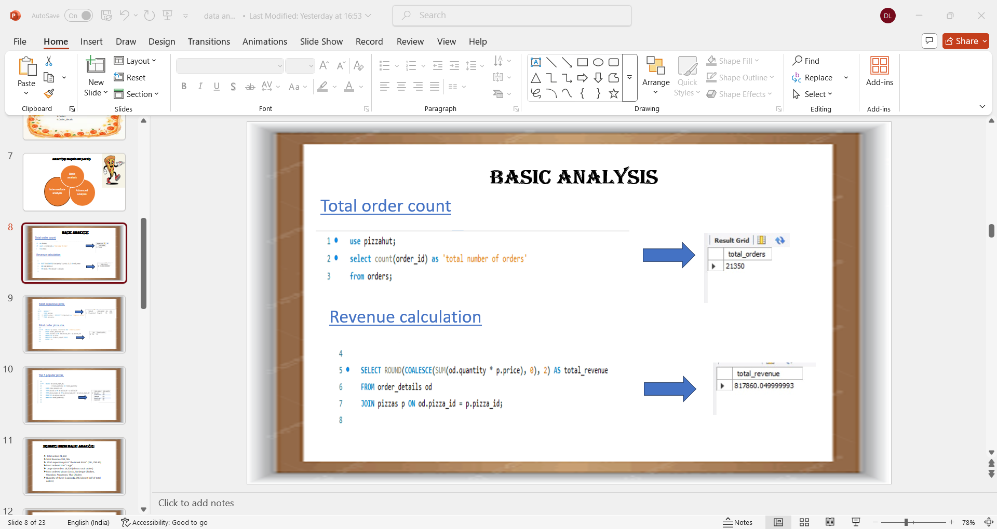
- Revenue calculation

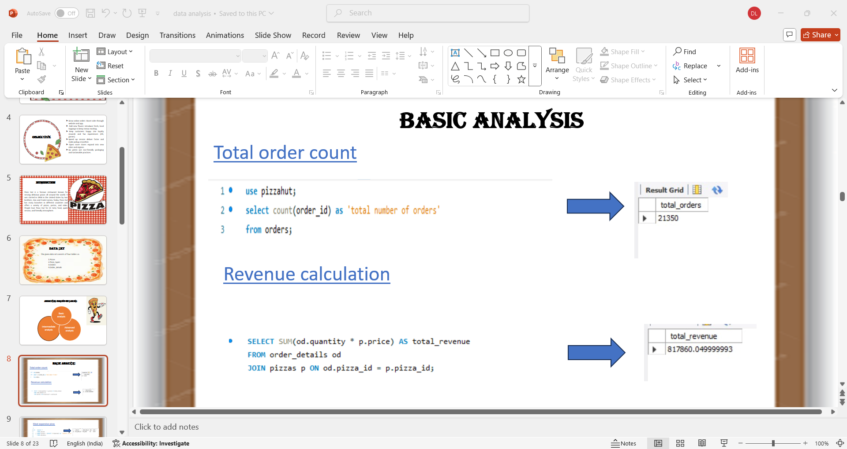

- Most expensive pizza

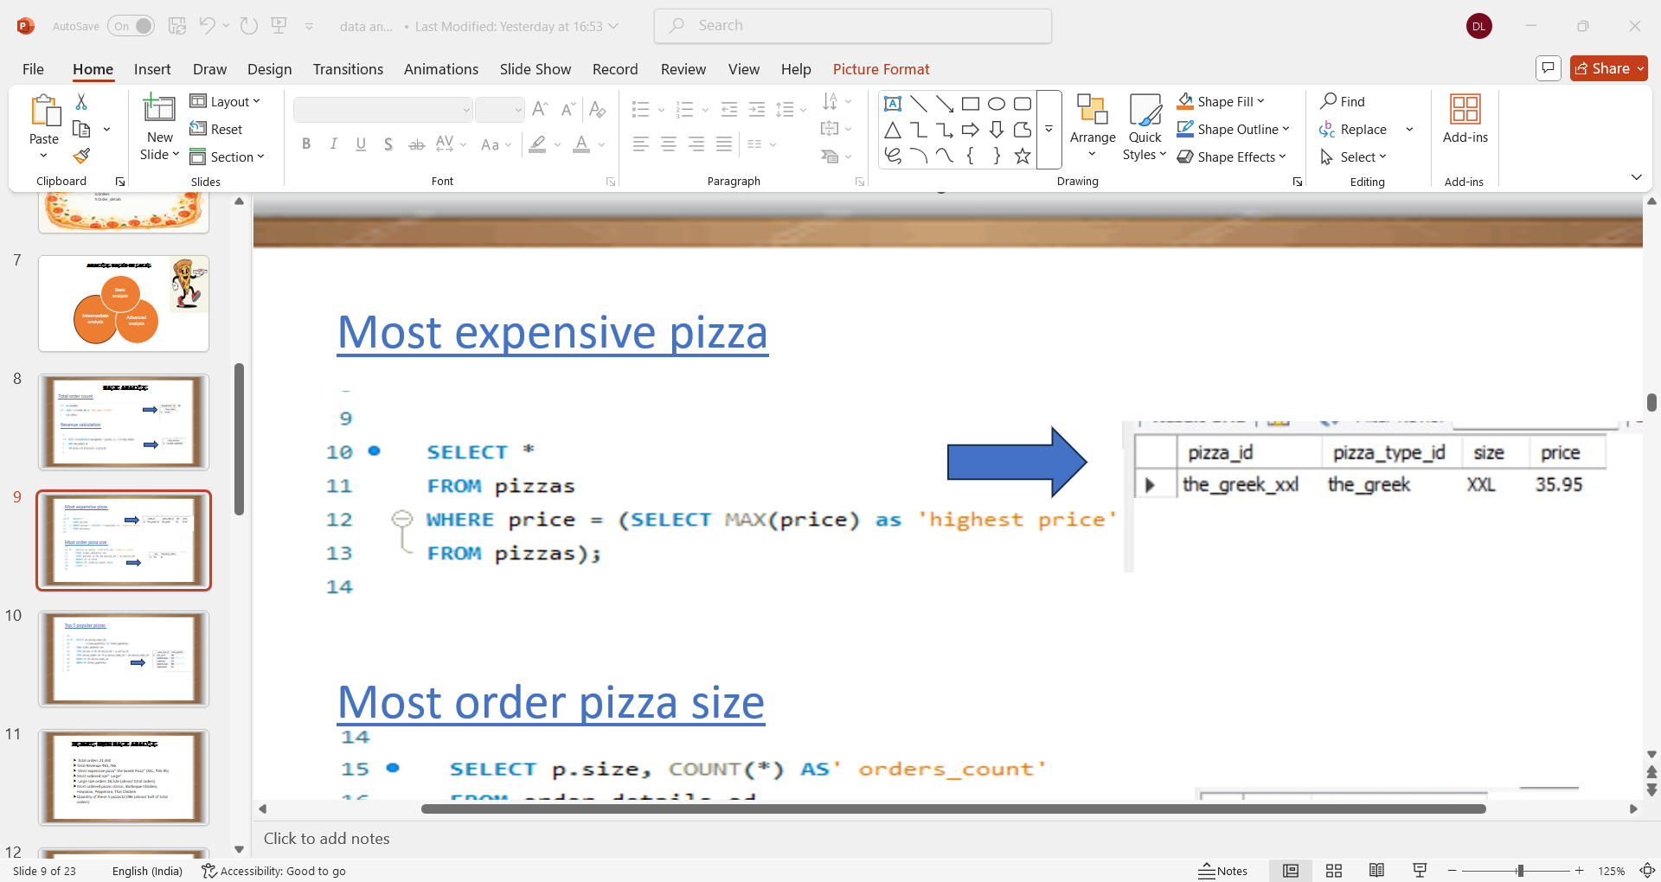

- Most order pizza size

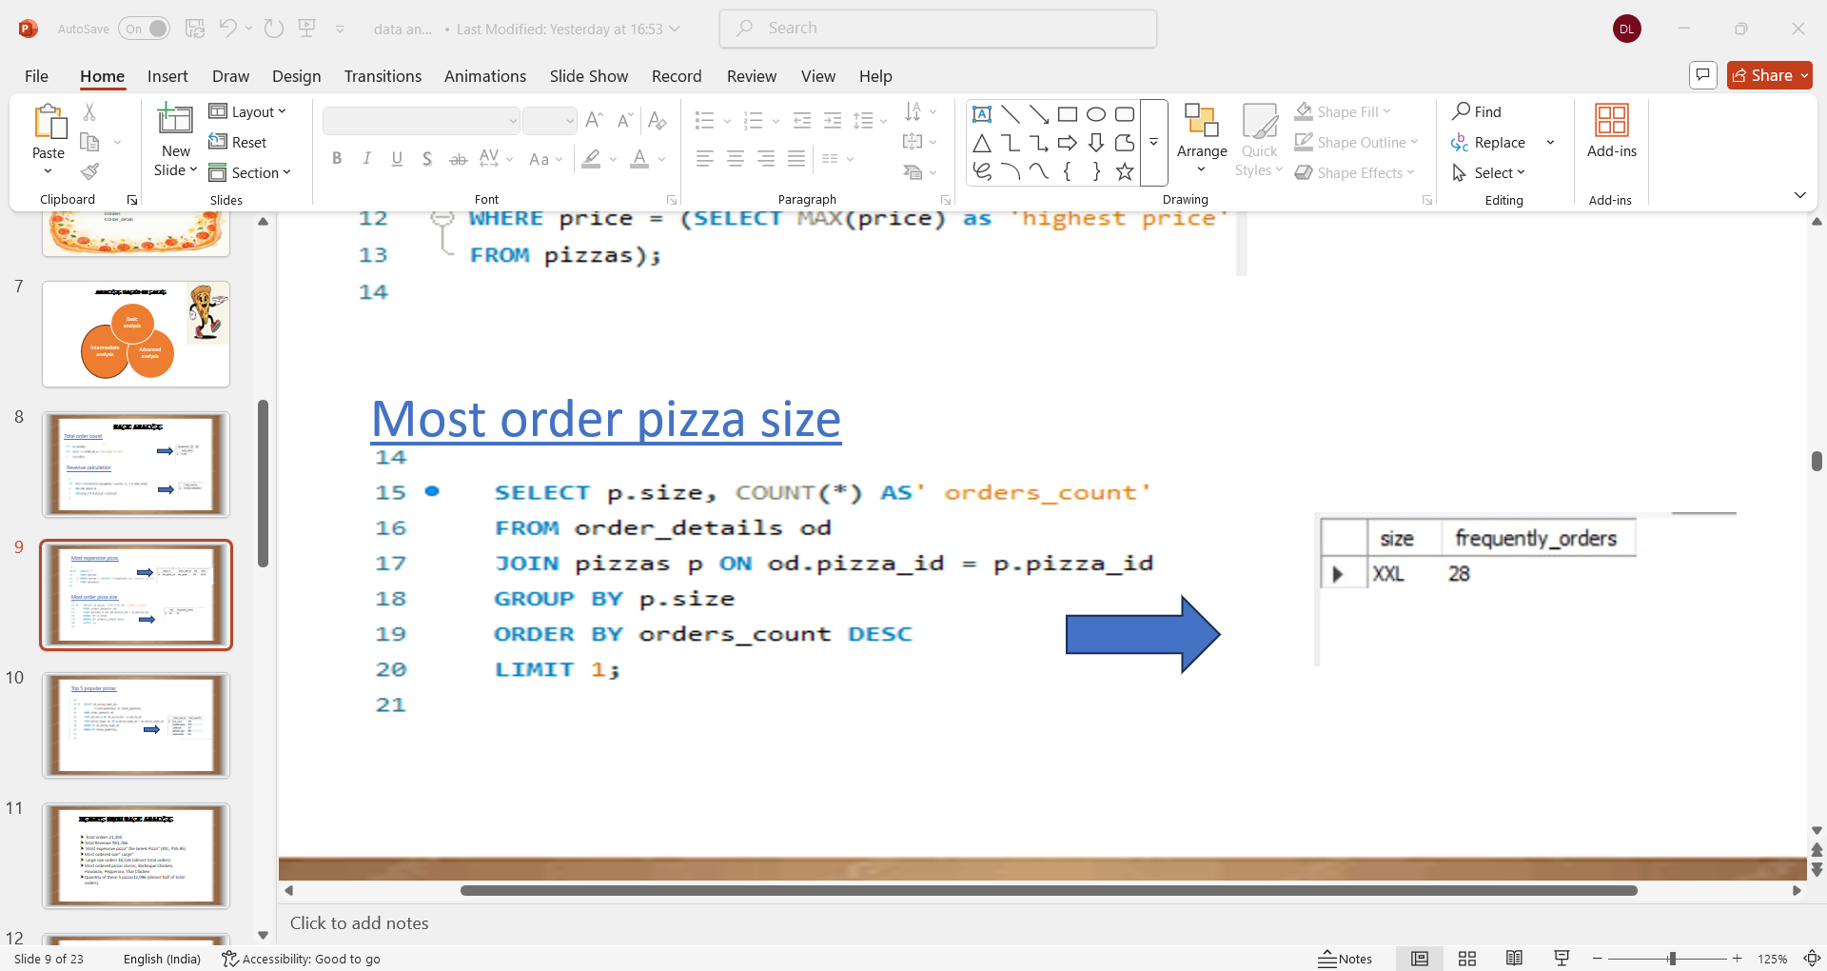

- Top 5 popular pizza

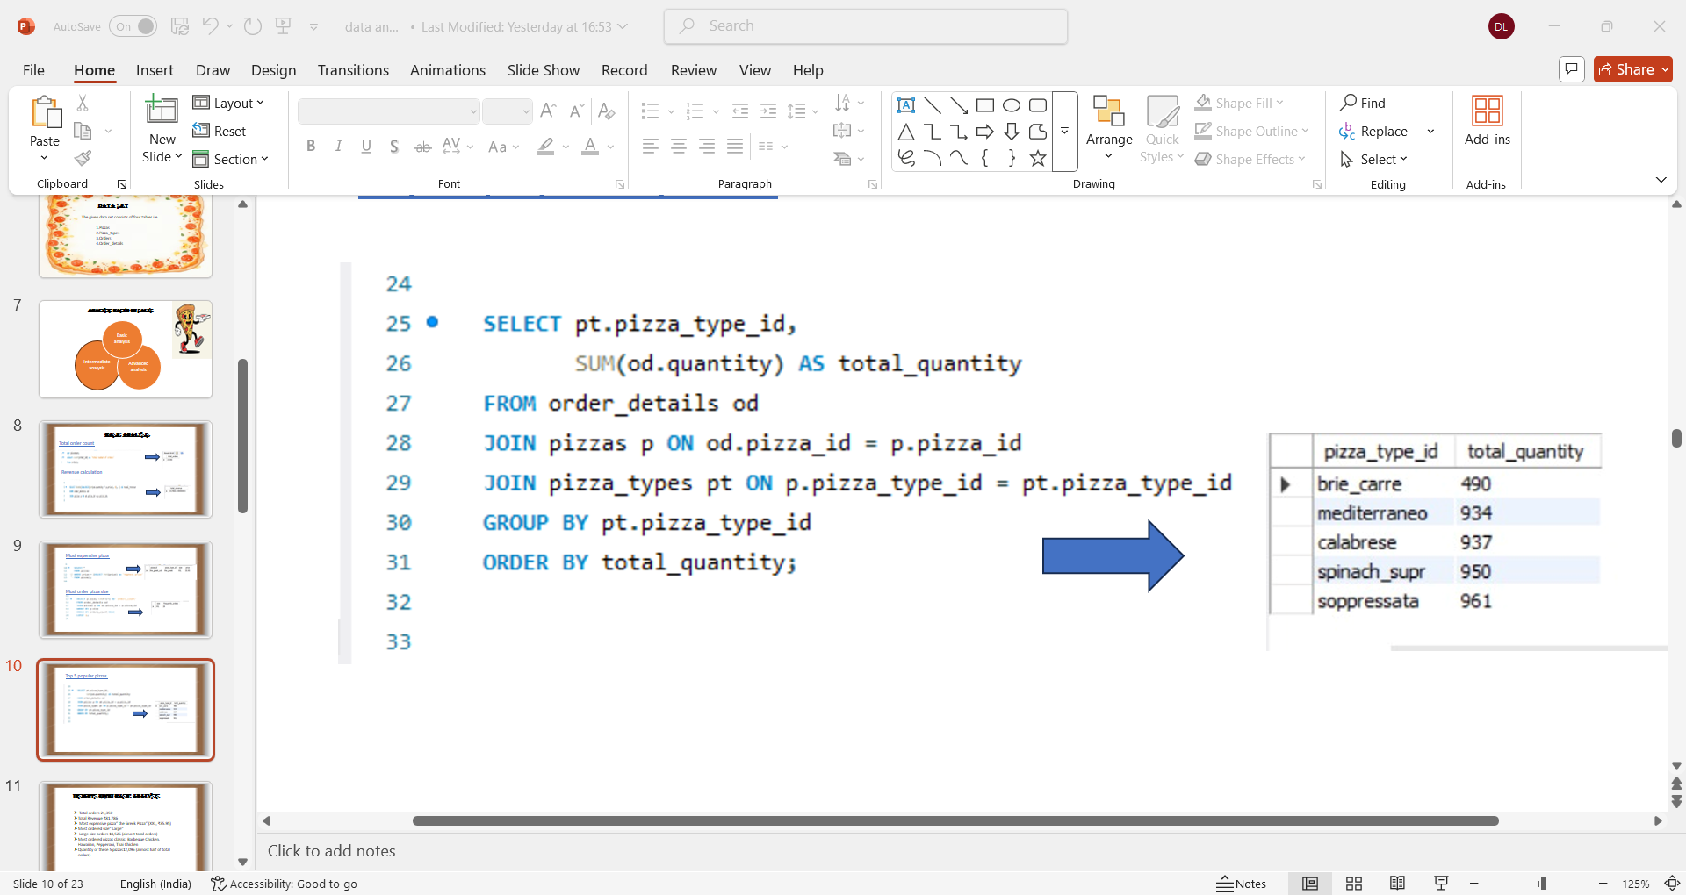

INSIGHTS FROM BASCI ANALYSIS

- Total Orders: 21,350

- Total Revenue: ₹81,786

- Most Expensive Pizza: The Greek Pizza (XXL – ₹35.95)

- Most Ordered Size: Large

- Large Size Orders: 18,526 (nearly 87% of total orders)

- Most Ordered Pizza Types: Classic, Barbeque Chicken, Hawaiian, Pepperoni, and Thai Chicken

- Quantity of Top 5 Pizzas: 12,096 (almost half of total orders)

INTERMEDIATE ANALYSIS

At this stage, deeper relationships between different data points are explored. Examples include:

- Identifying top-selling pizzas and best-performing categories.

- Calculating average order value.

- Determining peak ordering hours and high-demand days.

- Analysing regional preferences or customer demographics if available

INTERMEDIATE CASE STUDY ANALYSIS

- Pizza quantity by category

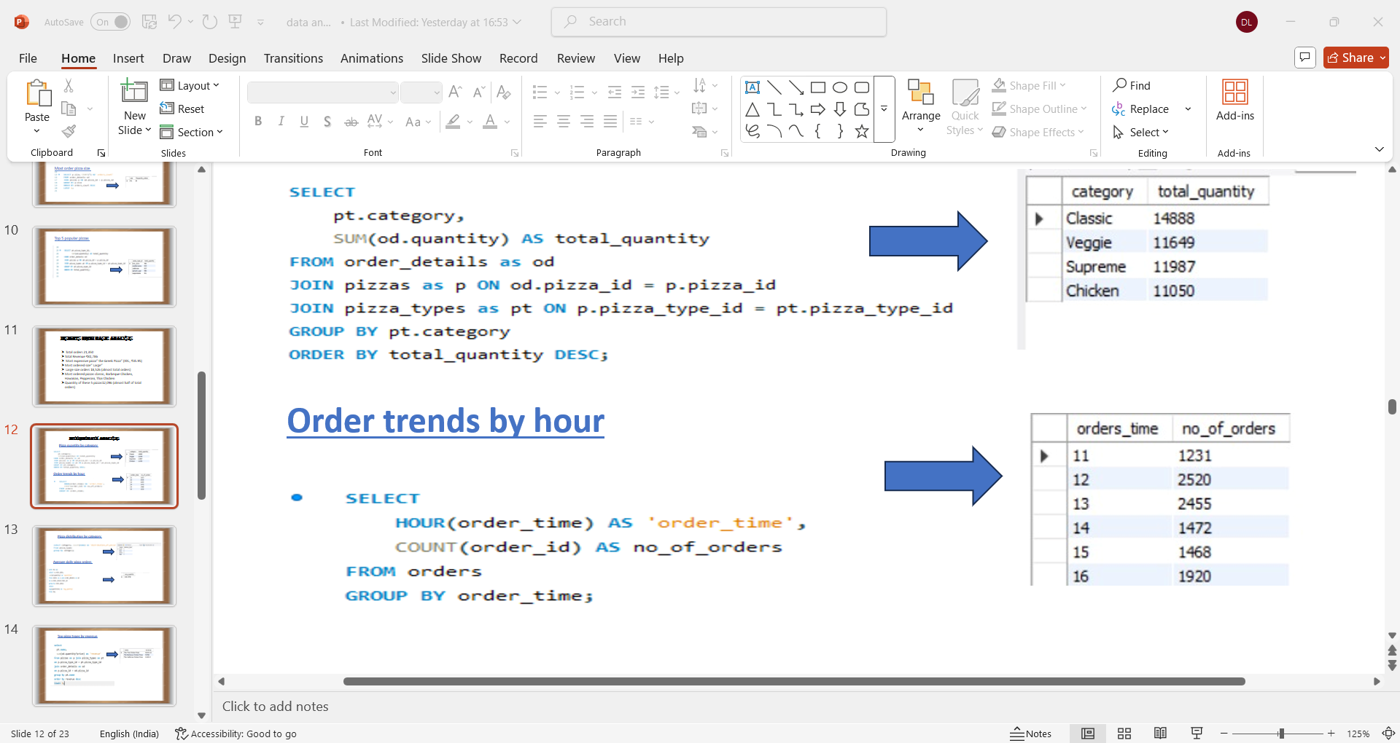

- Order trends by hour
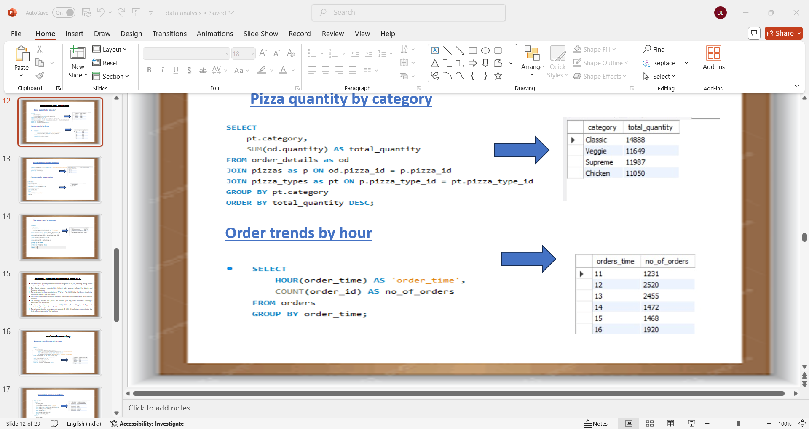

- Pizza distribution by category

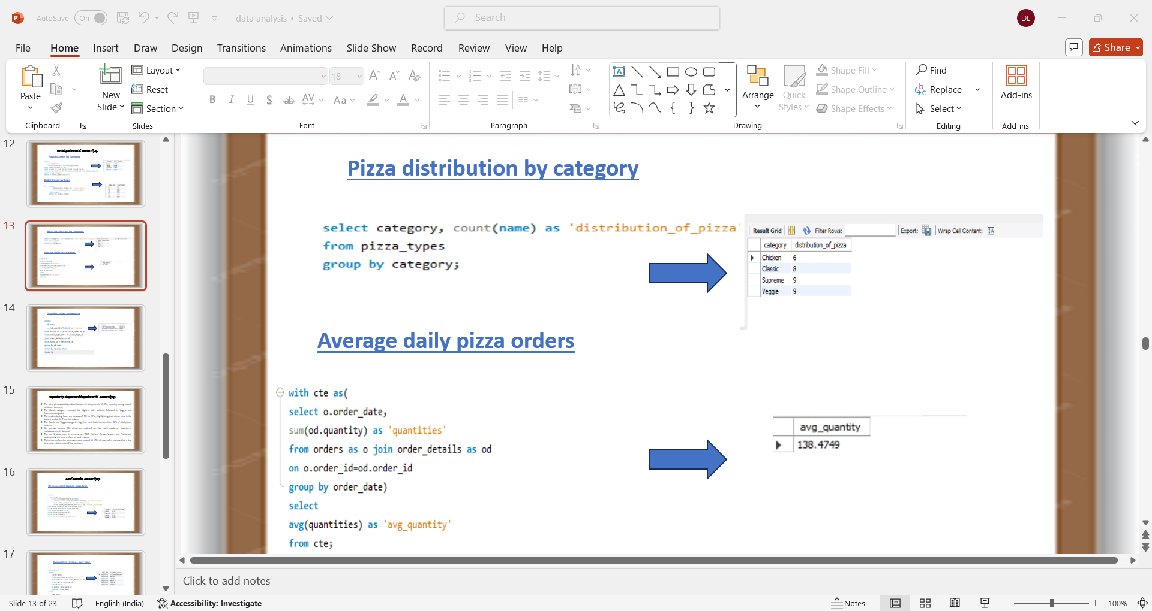

- Average daily pizza orders



- Top pizza type revenue

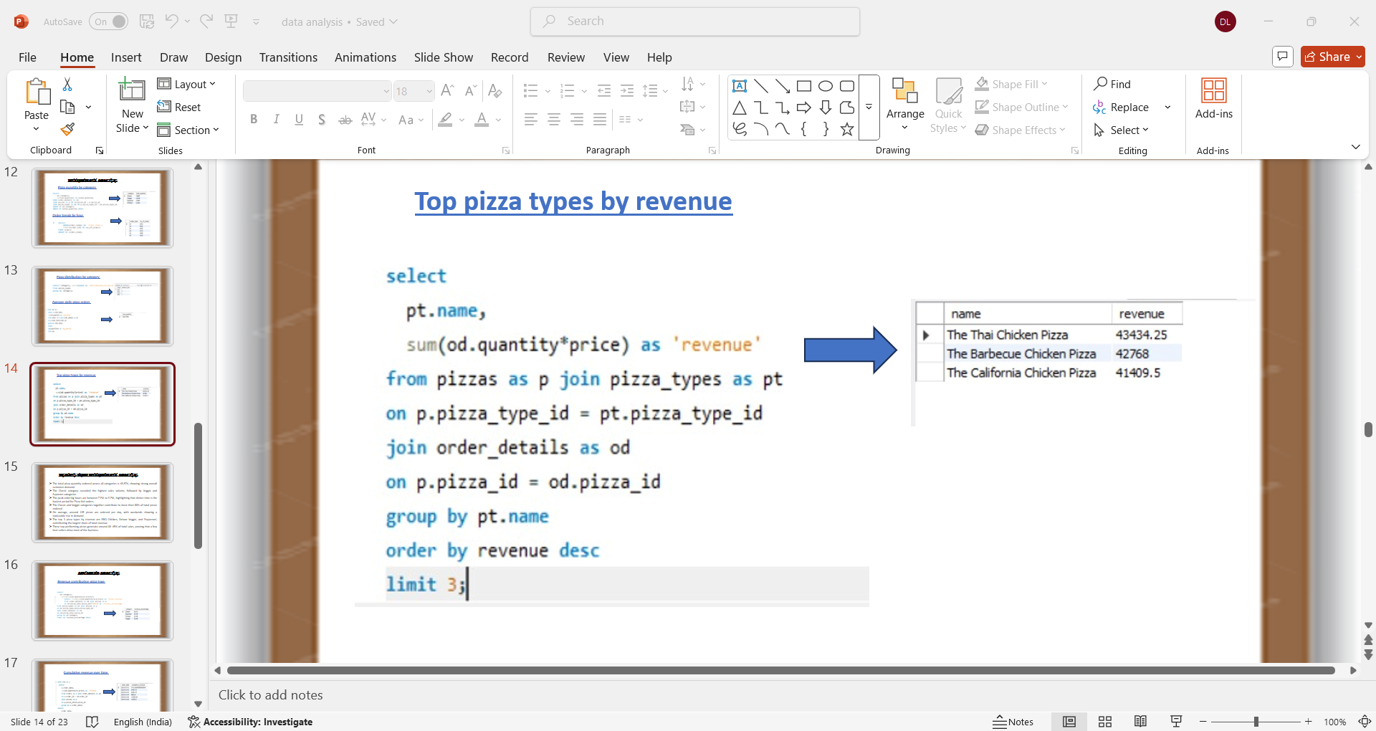

.

INSIGHTS FROM INTERMEDIATE ANALYSIS

- Total pizzas ordered: 49,574, showing strong customer demand.

- Classic category recorded the highest sales, followed by Veggie and Supreme.

- Peak hours are from 7 PM to 9 PM, the busiest time for Pizza Hut orders.

- Classic and Veggie pizzas contribute to over 60% of total orders.

- On average, 135 pizzas are ordered per day, with higher weekend demand.

- Top 3 pizza types by revenue: BBQ Chicken, Deluxe Veggie, and Pepperoni.

- These top-performing pizzas generate 40–45% of total sales, proving that a few best-sellers drive the majority of business.

ADVANCED ANALYSIS

The revenue contribution by category, top-performing pizzas, category-based revenue leaders, and revenue trends over time. These insights enable data-driven decision-making and help Pizza Hut improve its product mix and marketing strategies.

• Forecast future sales trends.

• Evaluate the contribution of each pizza category to total revenue.

• Identify underperforming items that may be removed or improved.

• Build data-driven recommendations for pricing, promotions, and resource allocation.

• This level of analysis supports strategic decision-making and long-term planning for Pizza Hut’s growth and profitability.

ADVANCED CASE STUDY ANALYSIS

- Revenue contribution pizza type

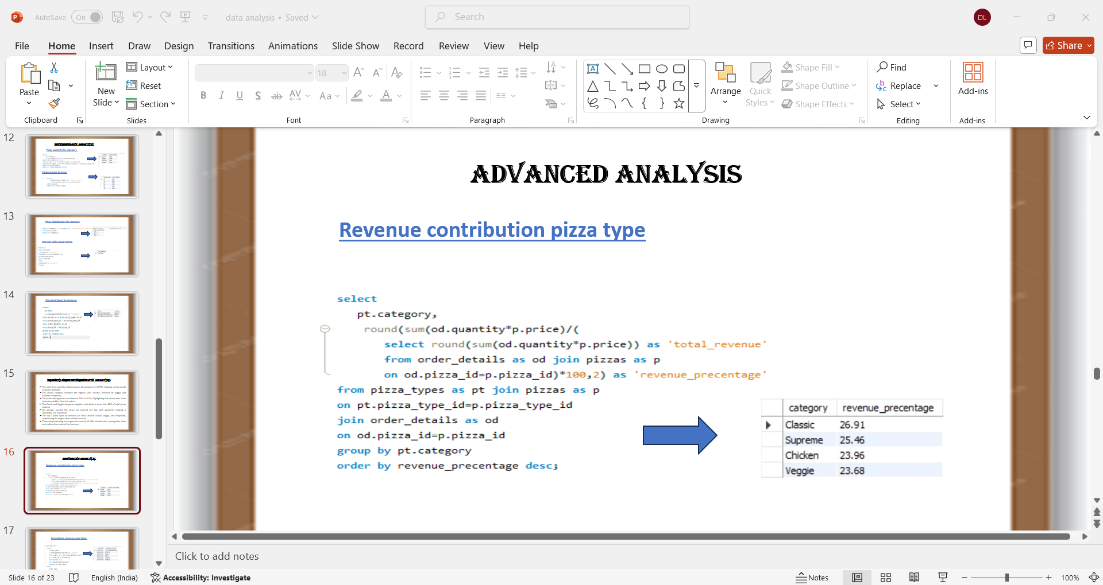
- Cumulative revenue over time

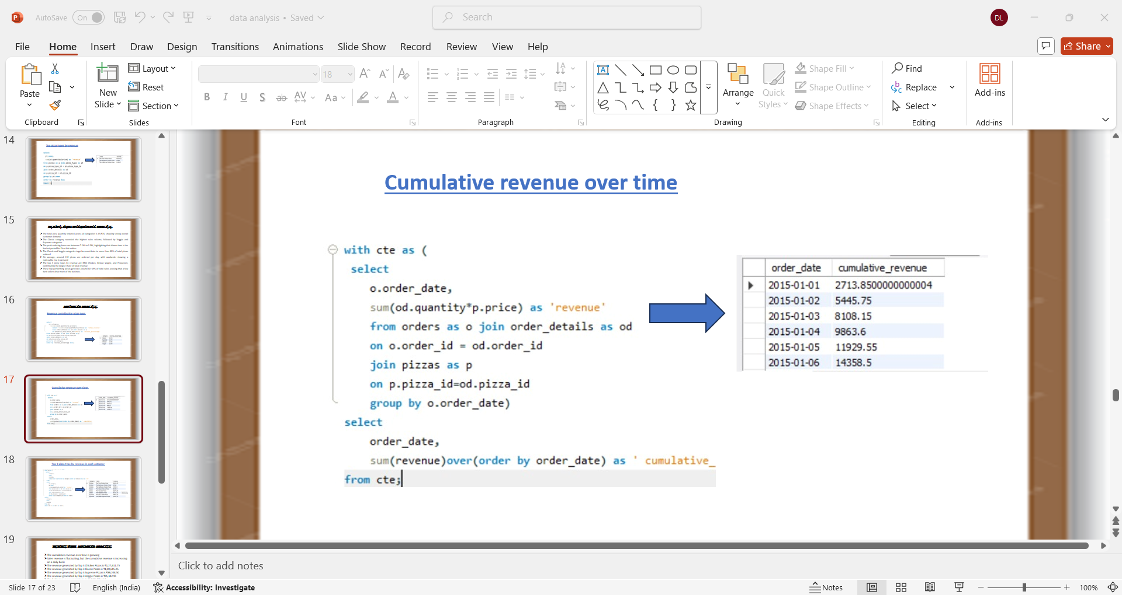

- Top 3 pizza type by revenue in each category

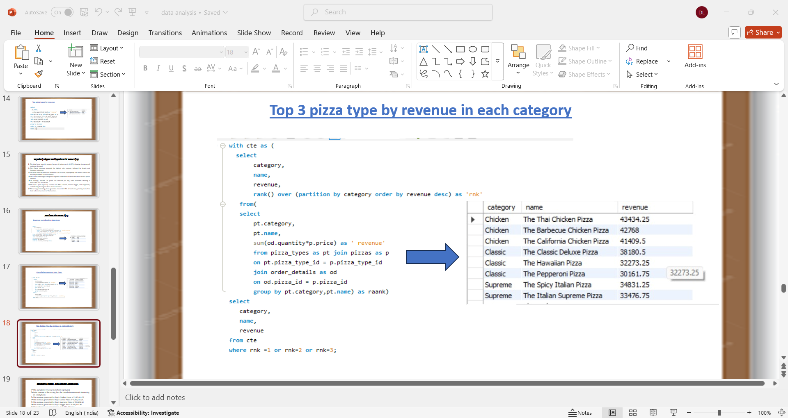

INSIGHTS FROM ADVANCED ANALYSIS

- The revenue generated by the top 3 Chicken Pizzas is ₹1,27,611.75.

- The revenue generated by the top 3 Classic Pizzas is ₹1,00,615.25.

- The revenue generated by the top 3 Supreme Pizzas is ₹99,248.50.

- The revenue generated by the top 3 Veggie Pizzas is ₹85,112.95.

- The highest revenue percentage is from the Classic category (26.91%).

- The lowest revenue percentage is from the Veggie category (23.68%).

RECOMMADICATIONS

The dataset provides the complete information of Pizza Hut’s annual sales performance for one year.
The total number of customer orders recorded is 21,350.

Based on the findings from the analysis, several actionable recommendations are proposed to improve Pizza Hut’s sales, product performance, and customer engagement:

- Introduce Combo Offers:
Combine low-selling pizzas with popular ones to attract new customers and boost overall order value.

- Promote Least-Selling Pizzas:
Offer discounts or add-ons such as garlic bread or beverages with pizzas that have lower demand, encouraging customers to try new varieties.

- Launch Morning Offers:
Create special breakfast or early-hour combos between 9 AM to 11 AM to expand sales beyond typical lunch and dinner hours.

- Target Corporate Customers:
Provide special packages and discounts for offices, corporate clients, and MNCs, focusing on bulk lunch or team orders. It was also observed that the least sold pizza sizes are XL and XXL.
To increase demand for these sizes, Pizza Hut can offer corporate discounts and group meal offers for companies, offices, and startups.

- Customer Loyalty Program:
Introduce reward points or membership benefits for frequent customers to encourage repeat purchases and brand loyalty.

- Online Promotions:
Strengthen social media visibility through promotional campaigns and offer exclusive discounts for app users to increase digital engagement.

- Focus on Low-Revenue Pizzas:
Introduce combo deals or feature special promotions for pizzas with comparatively lower sales.
Examples include:
a) Brie Cheese Delight Pizza
b) Fresh Garden Veggie Pizza
c) Spinach Supreme Pizza
d) Mediterranean Flavour Pizza
e) Spinach Pesto Special

CONCLUSION

- Pizza Hut is one of the most popular pizza brands, known for its quality, taste, and service.
- The data analysis shows that Large pizzas are ordered the most by customers.
- Classic and Veggie pizzas are the most loved categories
- Most orders are placed in the evening hours, especially on weekends.
- A few top pizzas like BBQ Chicken and Deluxe Veggie bring in the highest revenue

